Carnegie Mellon University – NSE TalentSprint
Advanced Certificate Program in DevOps
Cohort 04: Mar 2024 – Sep 2024
Capstone Project Module
Group 4 – Strengthening a basic CI pipeline for a project migrating to microservice architecture
Project Report
- Ajay Kumar Srivastava
- Sagar Rajen Kapadia
- Santosh P
- Yinebeb

Table of Contents
Abstract 3
Introduction 4
Objective 5
Background 6
Methodology 7
Implementation Details 8
Decision points 9
Mono repo vs Poly Repo 9
CI/CD Server 10
Static Code Analysis and Code Coverage 12
Findings 13
Discussion 14
Conclusion 16
References 16

Abstract
This report presents a comprehensive approach to strengthening a basic Continuous Integration (CI) and Continuous deployment (CD) pipeline in the context of migrating from a monolithic to a microservices-based architecture. The project focuses on enhancing the CI pipeline to meet the demands of a microservices environment by integrating advanced code quality checks, automated testing, and infrastructure management.
To improve the pipeline, we:
- Split services into separate repositories: This enabled independent development, deployment, and scaling of individual microservices, leading to improved focus, testing, maintainability, and technology agnosticism.
- Automated test environment provisioning: We used Ansible to create consistent and reliable test environments for each microservice.
- Enhanced code quality: We integrated static analysis tools to identify potential code issues early in the development process. By implementing custom quality gates and enforcing a minimum of 80% code coverage, the CI pipeline ensures only high-quality code moves through the release process.
- Strengthened CI/CD pipeline: We added additional stages to the CI/CD pipeline, including code coverage checks and performance tests, to ensure higher quality releases.
By implementing these enhancements, we significantly improved the efficiency and scalability of the CI/CD pipeline, enabling faster development and deployment of microservices. This project demonstrates the benefits of adopting a microservices architecture and a well-structured DevOps pipeline.

Introduction
In today's fast-paced software development landscape, microservices architecture has emerged as a popular approach to building scalable, resilient, and maintainable applications. However, effectively managing and deploying microservices requires a robust CI/CD pipeline that can handle the complexities of a distributed system and ensure high code quality.
Our organization was facing challenges in maintaining a high-quality CI/CD pipeline for an application undergoing a migration to microservices architecture. The existing pipeline lacked strong quality checks, adequate code coverage, and efficient test environment management. These limitations resulted in slower development cycles, increased risk of defects, and difficulties in scaling the application.
The current CI pipeline is insufficient for the needs of a microservices architecture. It lacks strong quality checks, allowing code smells and vulnerabilities to enter the codebase. Specifically, there is a need for stronger quality check rules, which can be addressed by creating custom quality profiles and implementing quality gates to ensure only high-quality code is merged. Additionally, the build process does not enforce a minimum code coverage of 80% for unit tests, risking the introduction of untested code.
To further enhance code quality, linting should be included in the development process. This will help developers identify and fix code quality issues within their Integrated Development Environments (IDEs) before the code is submitted to the CI pipeline. Furthermore, performance and load tests need to be integrated into the Continuous Delivery (CD) pipeline to ensure that the microservices can handle high traffic and maintain reliability.
Another significant challenge is the manual maintenance of test environments. Provisioning and setting up servers for each release is tedious and time-consuming. To solve this, there is a need to automate the environment setup process and integrate it into the CI/CD pipeline, streamlining the workflow and reducing errors.
By addressing these issues with appropriate tools and practices, this project aims to create a more efficient and reliable CI/CD pipeline that supports the needs of a microservices architecture.

Objective
The primary objective of this project is to enhance the Continuous Integration (CI) and Continuous Deployment (CD) pipeline for an application transitioning from a monolithic to a microservices architecture. The specific objectives are as follows:
- Implement Stronger Quality Checks: Establish custom quality profiles and quality gates within the CI pipeline to enforce stricter rules for code quality. This will help catch issues early in the development process and maintain high standards for code contributions.
- Monitor Code Coverage: Ensure that unit tests cover at least 80% of the codebase. The build process should be configured to fail if this threshold is not met, thereby preventing untested code from being deployed.
- Integrate Linting: Incorporate linting tools into the development workflow. This will allow developers to identify and resolve code quality issues within their IDEs before code is pushed to the CI pipeline, reducing the chances of introducing errors.
- Add Performance and Load Testing: Integrate performance and load tests into the Continuous Delivery (CD) pipeline to validate that the microservices can handle expected user loads and maintain performance under stress.
- Automate Test Environment Provisioning: Automate the setup and provisioning of test environments using tools like Ansible. This will eliminate the manual steps currently required for each release, making the process faster and less error-prone.
- Streamline the CI/CD Workflow: Overall, the project aims to create a more efficient CI/CD workflow that supports rapid development cycles while ensuring code quality, reliability, and performance.

As the application moves to a microservices architecture, maintaining high code quality and efficient testing becomes crucial. By implementing these objectives, the project aims to reduce technical debt, improve collaboration among development teams, and accelerate the release process. This approach aligns with best practices in DevOps, ultimately leading to a more robust and scalable software delivery pipeline.

Background
As software development continues to evolve, many organizations are shifting from monolithic architectures to microservices architectures to enhance flexibility, scalability, and maintainability. A monolithic architecture tightly integrates all components of an application into a single unit, which can make it difficult to manage and deploy updates. In contrast, a microservices architecture breaks the application into smaller, independent services that can be developed, tested, and deployed separately. This shift allows for faster development cycles, as teams can work on different services simultaneously.
However, transitioning to microservices introduces new challenges, particularly in managing Continuous Integration (CI) and Continuous Delivery (CD) pipelines. In the current setup, the CI pipeline is basic and lacks the necessary checks and automation to support the needs of multiple microservices. Key requirements for the project include:
- Enhanced Code Quality: With multiple services being developed in parallel, ensuring high code quality becomes critical. Implementing stronger quality checks and monitoring code coverage helps maintain standards and prevents defects.
- Automation of Testing Processes: Manual testing and environment setup can slow down the release cycle. Automating these processes allows for quicker feedback and more efficient releases.
- Performance Validation: As microservices handle individual components of the application, it's essential to validate their performance under load. Integrating performance and load testing into the pipeline ensures that the services can handle expected traffic and function reliably.
- Streamlined Environment Management: The current manual provisioning of test environments is time-consuming and error-prone. Automating this process is necessary to improve efficiency and reduce the risk of configuration errors.
By addressing these requirements, the project aims to create a robust CI/CD pipeline that supports the needs of a microservices architecture, ultimately leading to improved software quality and faster delivery times.

Methodology
To address the challenges of enhancing the Continuous Integration (CI) pipeline for a microservices architecture, a systematic approach was employed. This methodology outlines the steps taken, the tools selected, and the reasoning behind these choices.
Approach
- Assessment of Current CI Pipeline: The first step involved a thorough evaluation of the existing CI pipeline to identify gaps in quality checks, testing, and automation. This assessment highlighted the need for stronger code quality rules, improved test coverage, and automated environment provisioning.
- Selection of Tools and Technologies:
  - Continuous Integration and Deployment: Jenkins was chosen as the CI/CD tool due to its flexibility and wide range of plugins. It allows for the integration of various stages of the pipeline seamlessly.
  - Code Quality Analysis: SonarQube was selected to provide comprehensive static code analysis. It offers customizable quality gates and supports various programming languages, making it suitable for a microservices architecture.
  - Testing Frameworks: JUnit and Mockito were utilized for unit testing. These frameworks are widely adopted in the Java ecosystem, making them familiar to the development team.
  - Linting Tools: ESLint and Prettier were incorporated to ensure code quality at the developer level, allowing for issues to be resolved early in the development process.
  - Performance Testing: The provided mono repo already had a load generator. The tool was used to simulate the load tests and performance metrics were captured by istio service mesh and the results were visualized using kiali dashboard.
  - Automation of provisioning hardware: Terraform was selected to provision the hardware required for test setup.
  - Automation of Environment Setup: Ansible was selected to automate the provisioning of test environments, enabling consistent and repeatable setups for every release.
- Task Prioritization: Tasks were prioritized based on their impact on the overall project goals. The most critical areas, which were part of MVP - code quality and automated performance testing were addressed first to establish a strong foundation. Automation of environment provisioning followed to streamline the workflow, and performance testing was added to ensure reliability.
- Assumptions Made:
  - It was assumed that the development team was familiar with the selected tools and could adapt quickly to any new processes.
  - The project team assumed that integrating these tools into the existing workflow would enhance productivity and not introduce significant overhead.
- Implementation Plan: A phased implementation plan was developed, focusing on gradual integration of tools and practices into the existing pipeline. Regular feedback loops were established to assess the effectiveness of each change and adjust as needed.

This methodology ensures a structured approach to improving the CI/CD pipeline, focusing on key areas that will enhance code quality, speed up testing, and automate repetitive tasks. By carefully selecting tools and prioritizing tasks, the project aims to create a robust and efficient development environment for the microservices architecture.

Implementation Details
Architecture Design
Overview
This section outlines the architecture and design used to implement the enhanced Continuous Integration (CI) pipeline for the microservices application. The implementation leverages various DevOps tools and practices to address the identified challenges effectively.
Key Components:
- Git repositories: Each microservice was placed in a separate Git repository to enable independent development and deployment.
- Jenkins: A CI/CD server was configured to automate the build, test, and deployment processes for each microservice.
- Docker: Microservices were containerized using Docker to ensure consistent environments and portability.
- Kubernetes: Kubernetes was used to orchestrate the deployment and management of microservices across multiple nodes.
- Ansible: Ansible was employed to automate the provisioning and configuration of infrastructure resources, such as test environments.
- Static analysis: SonarQube was integrated into the CI/CD pipeline to identify potential code quality issues.
- Code coverage: Sonarqube was used to measure code coverage and ensure adequate testing.
- Linting: SonarLint was integrated into the development environment to catch code quality issues early.
- Performance testing: Load generator with istio and kiali was used for running performance and evaluating the results.

Decision points

Mono repo vs Poly Repo
Feature | Mono Repo (All microservices in one repo) | Poly repo (One repo per microservice)
Dependency Management | Simplified management of shared libraries | More effort needed to sync dependencies across multiple repositories.
Versioning | Centralized versioning for all microservices, reducing compatibility issues. | Versioning is more complex, requiring careful tracking of inter-service compatibility.
Collaboration | Easier collaboration, as all microservices are in the same codebase. | Collaboration can be slower, requiring coordination across multiple repositories.
Build Complexity | Builds can be slow and complex, especially as the number of services increases. | Each service has a faster, independent build pipeline, optimized for that service.
CI/CD Pipeline | One CI/CD pipeline for all services, but can become slow and hard to scale. | Each microservice has its own pipeline, allowing faster, independent deployments.
Refactoring across service | Easier to refactor across multiple services in a single place. | Refactoring requires changes across multiple repositories, leading to more coordination.
Tooling overhead | Simplified tooling and setup since all services share the same environment and pipeline. | More tooling and infrastructure overhead to maintain multiple repositories and pipelines.
Deployment Speed | Slower, as all services may be tested and deployed together. | Faster, as each microservice can be tested and deployed independently.
Devops Maintenance | Easier initially, as there's only one set of CI/CD pipelines to manage. | More pipelines to manage, leading to increased complexity for DevOps teams.
Code Quality Enforcement | Easier to enforce consistent rules and checks across all services in the same repository. | Each service can have its own rules and checks, which may lead to inconsistency if not managed well.
Use case | Best for small projects or early-stage microservices architecture. | Best for large projects with many independent services that need to scale.

Conclusion
Since the Mono repo had 10+ microservices. It has become too large to handle and is suited for Poly repo. In addition to this, microservices were developed using different tech stack so having single CI/CD pipeline has become too complex. Having poly repo benefitted in using devops tools specific to the tech stack of a microservice.

CI/CD Server
Aspect | Self-Hosted Jenkins | GitHub Actions | GitLab CI | CircleCI
Hosting | Self-hosted, requires setup and maintenance. | Fully managed by GitHub. | Available as both self-hosted and GitLab-hosted. | Fully managed by CircleCI.
Cost | Free to use but incurs infrastructure and maintenance costs. | Free for public repositories, paid plans for private repos. | Free for public repos, pricing for private repos or self-hosting. | Free for open-source projects, pricing for private ones.
Setup & Maintenance | Requires manual setup, updates, and scaling (e.g., configuring agents, plugins). | Minimal setup, integrated with GitHub repositories. | Minimal setup for GitLab-hosted; more effort for self-hosted. | No maintenance required, CircleCI manages all infrastructure.
Customization | Highly customizable with extensive plugin ecosystem. | Limited customization, mainly focused on GitHub workflows. | Customizable, integrates well with GitLab’s ecosystem. | Moderately customizable, simpler configuration compared to Jenkins.
Integrations | Extensive integrations via plugins for various tools, languages, and platforms. | Native integration with GitHub, good support for popular tools. | Seamless integration with GitLab’s ecosystem and tools. | Integrates well with GitHub, Docker, AWS, and other tools.
Scalability | Can scale with additional agents, but requires manual effort for autoscaling. | Scales automatically with GitHub-hosted runners. | GitLab-hosted CI scales automatically; self-hosted needs manual scaling. | Automatic scaling with CircleCI infrastructure.
Pipeline Configuration | Flexible, configured via Jenkinsfile (written in Groovy) or GUI-based. | YAML-based configuration (`.github/workflows`). | YAML-based configuration (`.gitlab-ci.yml`). | YAML-based configuration (`.circleci/config.yml`).
Ease of Use | More complex due to manual setup, plugin management, and Jenkinsfile scripting. | Easy to use with straightforward GitHub integration. | Easy for GitLab users, integrates natively with GitLab repositories. | Easy to use with good documentation.
Performance | Dependent on the server infrastructure you provide. | Performance depends on GitHub’s infrastructure for hosted runners. | Good performance on GitLab-hosted; self-hosted varies. | High performance with CircleCI’s cloud infrastructure.
Security | Full control over security, but you need to implement patches, updates, and firewalls. | Managed by GitHub, good security features, but less control over the infrastructure. | Good security with GitLab-hosted, self-hosted requires manual security management. | Managed security, but less control over infrastructure.
Community & Support | Large community, strong plugin support, but requires some learning to navigate. | GitHub community and official GitHub support. | Strong community and support from GitLab. | Active community and CircleCI support.
Use Case | Best for teams needing high customization and control. Ideal for complex workflows. | Best for teams already using GitHub, needing simple workflows. | Best for teams using GitLab for SCM and looking for native integration. | Great for teams wanting a managed service with robust performance.

Conclusion
Since number of microservices are increasing in the organization, number of CI/CD pipelines, flexibility and control has become an important factor. Also, with increased number of pipelines the cost overhead is not going to be much. This is the reason that Jenkins is a right tool for the organization.

Static Code Analysis and Code Coverage
Aspect | SonarQube | CodeClimate | Coverity
Purpose | Static analysis, code quality, and coverage | Code quality, coverage, and maintainability | Static analysis, security vulnerabilities
Language Support | Supports over 25+ languages | Primarily JavaScript, Ruby, Python, Go, PHP | Supports C, C++, Java, and other languages
Integration | Integrates with Jenkins, GitLab, GitHub, etc. | GitHub, GitLab, Bitbucket, CI/CD systems | Integrates with CI tools, IDE plugins available
Customization | Highly customizable quality gates and profiles | Limited customization for static analysis | Highly customizable static analysis rules
Security | Detects security vulnerabilities (e.g., OWASP) | Security checks are minimal | Strong focus on security vulnerabilities
Code Coverage | Integrates with tools like JaCoCo, Coverage.py | Offers basic coverage metrics | Does not focus on code coverage directly
Reporting | Detailed dashboard and reports | Basic quality and maintainability reports | Detailed security and bug detection reports
Scalability | Can be scaled for enterprise use | Mostly for small to medium-sized projects | Used in large-scale enterprise environments
Ease of Use | Easy to use with a wide range of plugins | Simple setup, easy to use | More complex setup, steep learning curve
Performance | Can handle large projects but requires resources | Lightweight and fast | Heavyweight, requires significant resources
Community | Large open-source community, good documentation | Smaller community compared to SonarQube | Enterprise-level support, limited community
Cost | Free (open-source), paid for enterprise features | Free for basic use, paid for advanced features | Enterprise license, not free
Best For | Teams needing robust static analysis, coverage | Small to medium teams focusing on code quality | Enterprises focusing on security vulnerabilities

Conclusion
SonarQube stands out from the other tools listed as it offers both static analysis and code coverage features, making it a comprehensive solution for code quality management.

Proposed Jenkins Jobs
- Test system CD job per repo:
  - Purpose: Test changes in a dedicated environment before deployment to production.
  - Steps: Triggered on merge to test branch, perform build, static code analysis, unit tests, provision test environment, deploy microservice, and deploy other related services.
  - Improvements: A Staging environment can be setup which can be shared for testing. This will reduce the cost. The dedicated environment will be used for some special type of tests like performance test. We can also consider, parameterization of specific release of different microservices in the job, that would be helpful in compatibility testing.
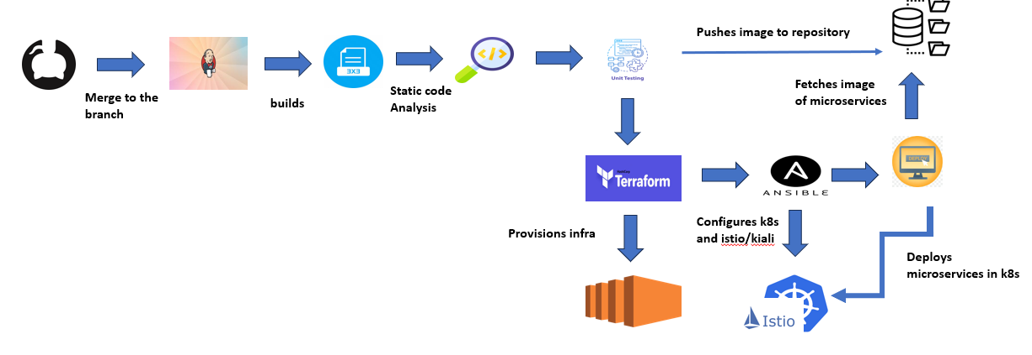

- Per PR per microservice CI job:
  - Purpose: Quick feedback on code changes.
  - Steps: Triggered on pull request, perform build, static code analysis, and unit tests.
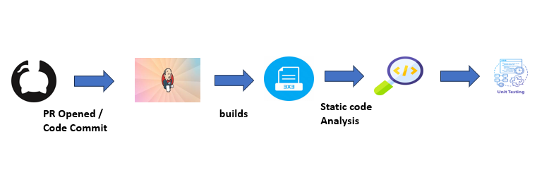
- One-time production deployment job:
  - Purpose: For initial setup or major infrastructure changes.
  - Steps: Provision VMs, configure Kubernetes, deploy microservices.
  - Assumption: Images are already present in repository server otherwise it needs a build phase.
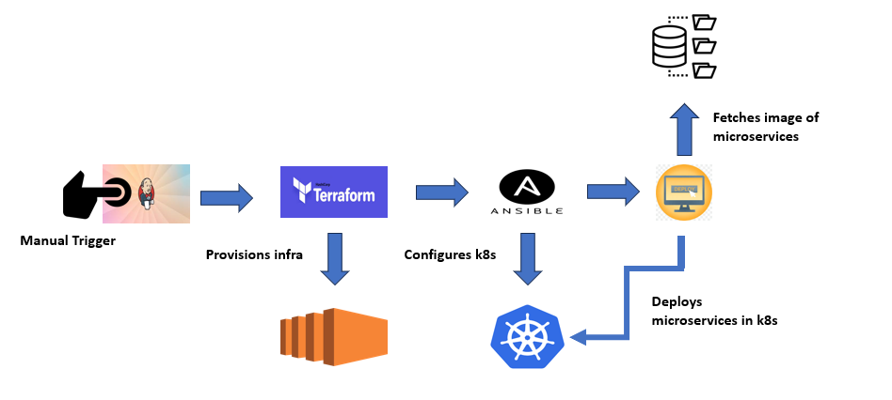
- Production continuous deployment job for each microservice:
  - Purpose: Continuous delivery of updates to production.
  - Steps: Triggered on merge to production branch, perform integration tests, deploy microservice to production.
  - Improvements: Implement blue-green deployments or canary releases for gradual rollout and reduced risk.
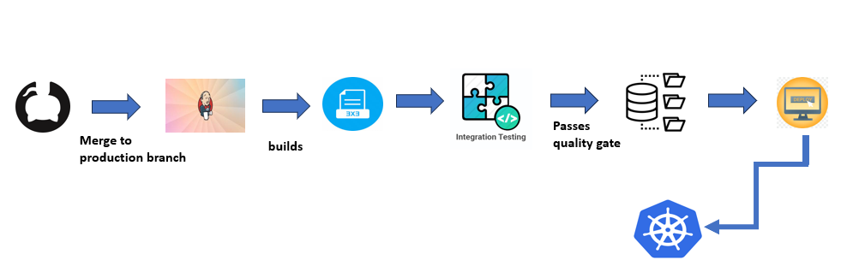
Additional Considerations
- Staging Environment: Add a staging environment between test and production for more realistic testing.
- Rollback Strategy: Implement a rollback strategy to revert changes if issues arise.
- Monitoring: Continuously monitor the CI/CD pipeline and microservices for performance and health.
- Security: Implement security measures to protect sensitive data and prevent unauthorized access.

Findings
This section presents the key results and observations from the project, along with the architectural decisions made during the planning and execution phases.
Main Results
- Improved Code Quality: By integrating SonarQube into the CI pipeline, the project successfully established custom quality gates. This resulted in a significant reduction in code smells and vulnerabilities, ensuring that only high-quality code was merged into the main branch. The enforcement of a minimum code coverage of 80% for unit tests helped to maintain a reliable codebase.
- Enhanced Testing Efficiency: The integration of unit tests using JUnit and Mockito, along with linting tools like ESLint and Prettier, streamlined the development process. Developers reported fewer bugs and issues during integration, as most problems were caught early in their workflow.
- Automated Environment Provisioning: Implementing Ansible for environment setup drastically reduced the time needed to provision test environments. This automation minimized manual errors and ensured consistency across environments, allowing for quicker deployment and testing cycles.
- Load Testing Insights: Performance testing with JMeter provided valuable insights into how the microservices behaved under load. It highlighted potential bottlenecks and areas for optimization, ensuring that the application can handle expected traffic without performance degradation.
Architectural Decisions
- Choice of CI/CD Tools: Jenkins was chosen as the CI/CD tool due to its flexibility and wide ecosystem of plugins. This decision was made to accommodate various integration requirements and provide a scalable solution as the project grows.
- Static Code Analysis: The use of SonarQube was driven by its comprehensive capabilities in analyzing code quality and providing actionable insights. The ability to customize quality profiles was a key factor in ensuring that the tool met the specific needs of the microservices architecture.
- Testing Framework Selection: JUnit and Mockito were selected for unit testing because of their popularity and strong community support within the Java ecosystem. Their familiarity among the development team facilitated quicker adoption and integration into the CI pipeline.
- Linting Integration: The decision to use ESLint and Prettier stemmed from their ability to maintain coding standards and improve code readability. Integrating these tools early in the development process helped catch issues before they reached the CI pipeline.
- Automation with Ansible: Ansible was chosen for its simplicity and effectiveness in automating environment setups. Its playbook approach allowed the team to define configurations in a clear and repeatable manner, which was critical for managing multiple microservices.

Overall, the project successfully enhanced the CI/CD pipeline to support the new microservices architecture. The strategic choices in tools and architectural design decisions contributed to improved code quality, faster testing cycles, and more efficient deployment processes. The findings underscore the importance of integrating automation and quality checks in modern software development practices.

Discussion
The findings from this project reveal significant improvements in the Continuous Integration (CI) pipeline for the microservices architecture. The integration of automated quality checks, testing frameworks, and environment provisioning has led to a more robust and efficient development process. This discussion analyzes these results in the context of the initial problem statement and highlights the implications for the organization moving forward.
Analysis of Findings
- Enhanced Code Quality and Team Efficiency: The introduction of SonarQube and strict quality gates has resulted in a measurable increase in code quality. Developers are now more aware of coding standards, leading to fewer bugs and issues during integration. This not only improves team efficiency but also builds confidence in the software being delivered.
- Faster Release Cycles: With the automation of testing and environment provisioning using Jenkins and Ansible, the overall time taken for each release has decreased significantly. This aligns with the objectives of adopting DevOps practices, allowing for quicker iterations and more frequent releases. This agility is crucial in a competitive market, where faster time-to-market can be a key differentiator.
- Performance Validation: The implementation of load testing with JMeter has highlighted potential performance bottlenecks. Addressing these issues early in the development cycle ensures that the microservices are not only functional but also scalable under high load. This proactive approach reduces the risk of performance-related incidents in production, which can lead to user dissatisfaction and loss of trust.
Implications and Significance
The successful enhancement of the CI pipeline demonstrates the value of investing in quality tools and practices in software development. It emphasizes the importance of automation in reducing manual effort and improving reliability. As the organization continues its DevOps journey, these improvements can serve as a foundation for further advancements in software delivery.
Future Steps for Improvement
- Continuous Monitoring and Feedback Loops: Implementing continuous monitoring tools (e.g., Prometheus, Grafana) to track application performance in real-time can provide insights that inform future development. This recommendation stems from the need to ensure that the application maintains performance post-deployment.
- Integration of Security Testing: Incorporating security scanning tools (e.g., Snyk, OWASP ZAP) into the CI/CD pipeline can enhance security measures. As the application evolves, addressing security vulnerabilities early in the development process is essential to protect against potential threats.
- Expand Test Coverage: Increasing the scope of testing to include integration and end-to-end tests can provide a more comprehensive assessment of the application’s behavior. This recommendation is based on the realization that unit tests alone may not catch all potential issues in a microservices environment.
- Documentation and Knowledge Sharing: Establishing clear documentation and knowledge-sharing practices among team members can facilitate smoother onboarding of new developers and ensure that best practices are followed consistently. This is vital for maintaining the quality and efficiency of the development process as the team grows.

In conclusion, the improvements made to the CI pipeline have addressed the initial challenges of transitioning to a microservices architecture. The findings underscore the importance of quality and automation in software development, while the recommendations for future steps provide a pathway for continuous improvement. By adopting these practices, the organization can further enhance its development capabilities and maintain a competitive edge in the industry.

Conclusion
This project successfully addressed the challenges associated with enhancing the Continuous Integration (CI) pipeline for a microservices architecture. Key findings reveal that the integration of automated quality checks, testing frameworks, and environment provisioning significantly improved code quality and streamlined the development process. By implementing tools such as SonarQube, Jenkins, and Ansible, the project established a more robust CI/CD pipeline that supports efficient development and faster release cycles.
The recommendations for future improvements include:
- Continuous Monitoring: Implementing monitoring tools to track application performance in real-time.
- Security Testing: Integrating security scanning into the CI/CD pipeline to identify vulnerabilities early.
- Expanded Test Coverage: Incorporating integration and end-to-end tests for comprehensive validation.
- Documentation and Knowledge Sharing: Establishing clear documentation practices to facilitate onboarding and ensure adherence to best practices.
By following these recommendations, the organization can continue to enhance its software delivery capabilities, ensuring high quality and reliability in its microservices architecture. This project lays the groundwork for a more agile, responsive, and secure development environment, aligning with the broader goals of DevOps adoption.

References
CI/CD Tools:
Jenkins: https://www.jenkins.io/
GitHub Actions: https://docs.github.com/actions
GitLab CI/CD: https://docs.gitlab.com/ee/ci/
CircleCI: https://circleci.com/
Travis CI: https://www.travis-ci.com/
Bamboo: https://www.atlassian.com/software/bamboo
TeamCity: https://www.jetbrains.com/teamcity/
Static Analysis and Code Coverage Tools:
SonarQube: https://docs.sonarsource.com/sonarqube/latest/
Checkstyle: https://sourceforge.net/projects/checkstyle/
PMD: https://pmd.github.io/
FindBugs: https://findbugs.sourceforge.net/downloads.html
Cobertura: https://sourceforge.net/projects/cobertura/
JaCoCo: https://www.baeldung.com/jacoco
Infrastructure as Code Tools:
Ansible: https://www.redhat.com/en/technologies/management/ansible/configuration-management
Terraform: https://www.terraform.io/use-cases/infrastructure-as-code
CloudFormation: https://console.aws.amazon.com/cloudformation/
Containerization and Orchestration Tools:
Docker: https://www.docker.com/
Kubernetes: https://kubernetes.io/

